Swinburne University of Technology

Computer Science

Assignment 1

**Research into AI Ethics & Responsible AI**

*Student:*

**Unit: Introduction to Artificial Intelligent**

*Tutorial:* Bao Khoa

Binh Thai Nguyen (104188845)

[Upek Malankandalage](https://swinburne.instructure.com/groups/174740/users/430040) (104532824)

[Krishan Ramesh](https://swinburne.instructure.com/groups/174740/users/453608) (104829429)

[Minh Huynh](https://swinburne.instructure.com/groups/174740/users/414562) (104320456)

April 13, 2025



**Contents**

Instructions 2

Introduction 3

Features/ Bugs/ Missing 4

Features Implemented 4

General Structure 4

Search Algorithms 4

Graph parsing and Handling 5

Distance Estimation 5

Visualization 5

Automated Testing Framework 5

Testing 5

Test case results 6

Insights 9

Additional Research 10

Conclusion 11

Acknowledgement /Resources 11

References 11

# Instructions

**Overview**

This program is designed to solve the **Route Finding Problem** using six tree-based search algorithms. It identifies the optimal path from an origin node to one or more destination nodes on a graph defined in a text file. The program supports both **uninformed** and **informed** search methods, as well as custom algorithms.

**Supported Algorithms:**

1. **DFS (Depth-First Search)**
2. **BFS (Breadth-First Search)**
3. **GBFS (Greedy Best-First Search)**
4. *A (A Star)*\*
5. **CUS1 (Iterative Deepening Depth-First Search)**
6. *CUS2 (Weighted A)*\*

Command-Line Usage

The program operates via the command line and supports batch testing of multiple search methods across various test cases.

**Syntax:**

python search.py <filename> <method>

**Arguments:**

1. <filename>: Path to the text file containing the graph definition.
2. <method>: Name of the search algorithm to use (DFS, BFS, GBFS, AS, CUS1, CUS2).

**Example:**

python search.py test_cases/test1.txt DFS

This command runs the Depth-First Search algorithm on the graph defined in test1.txt.

Input File Format

The input files must follow a specific format:

1. **Nodes:**  
   Each node is defined with its ID and coordinates:  
   Example: 1: (4,1) defines node 1 at coordinates (4,1).
2. **Edges:**  
   Each edge specifies the connection between two nodes and its cost:  
   Example: (2,1): 4 defines an edge from node 2 to node 1 with a cost of 4.
3. **Origin:**  
   Specifies the starting node:  
   Example: Origin: 2.
4. **Destinations:**  
   Specifies one or more destination nodes, separated by semicolons (;):  
   Example: Destinations: 5; 4.

Output Format

When a solution is found, the program outputs the following information:

<filename> <method>

<goal> <number_of_nodes>

<path>

**Example Output:**

test_cases/test1.txt DFS

4 7

2 -> 3 -> 4

Explanation:

* The goal node reached is 4.
* The algorithm created 7 nodes during execution.
* The path taken is 2 -> 3 -> 4.

If no solution exists, it outputs:

No solution found using <method> on <filename>

Features and Limitations

**Features Implemented:**

* Modular design with classes for graph parsing and individual algorithms.
* Support for multiple search strategies.
* Automated testing framework with performance metrics.
* Graph visualization showing nodes, edges, and paths.

**Known Bugs/Limitations:**

1. **Disconnected Graphs:** Some algorithms may take longer to identify cases where no solution exists.
2. **Depth Limit for CUS1:** Iterative Deepening DFS has a default depth limit of 30.
3. **Tie-Breaking Bias:** Nodes are expanded based on ascending order of IDs, which may bias solutions in certain graphs.
4. **No GUI:** Input/output is handled via command line; no graphical interface is available.

Testing Framework

The program includes an automated testing framework (test_framework2.py) that evaluates all algorithms against predefined test cases.

**Test Cases:**

The framework generates test cases with varying complexity, including:

* Small graphs with multiple paths.
* Large grid-like graphs.
* Disconnected graphs.
* Cyclic paths.

**Metrics Captured:**

* Path length and total cost.
* Execution time (in seconds).
* Number of nodes created during runtime.

Visualization

The program generates visualizations for each test case and algorithm run:

1. Graph layout showing nodes and edges.
2. Paths taken by each algorithm.

Visualizations are saved as PNG files in designated directories (test_visualizations/ and test_paths/).

# Introduction

This report is about the implementation and analysis of multiple tree-based search algorithms to solve the **Route Finding Problem** where the goal is to find the most efficient path from origin mode which is the starting point to one or more destinations on a 2D map depicted as a graph. In addition, developing efficient search algorithms which can identify a solution path with minimal cost while satisfying constraints. The graph is defined using simple textual format containing node coordinates, edge costs, a single origin, and one or more destinations. Some paths are one-way only, which adds to the complexity of the problem.

Therefore, we came up with six different tree-based search algorithms from scratch to solve this problem using python. These include informed and uninformed strategies where some of them blindly explore the graph without the idea where the goal destination(s) located. Meanwhile others make smart guesses to get to the destination(s) faster.

Here is a quick overview of those six strategies and these will be discussed further later in the report.

**Uninformed Methods**

DFS (Depth – First Search): A memory-efficient method that explores a path to its maximum depth before backtracking (select one option, go back when there are no more options after trying it). This is fast and uses little memory but does not always find the best path.

BFS (Breadth-First Search): expand all options one level at a time while ensuring the shortest path which might uses a lot of memory.

**Informed Methods**

GBFS (Greedy Best First Search: Uses only cost to reach the goal from the current node to evaluate the node which is usually faster but not always accurate.

A* (A Star): Use both the cost to reach the goal from the current node and the cost to find the closest path for the destinations. This strategy finds the most efficient paths overall.

**Customs**

CUS1 (Iterative Deepening Depth-First Search (IDDFS):

CUS2 (Weighted A*)

The solutions are designed to read in graph data from text files, interpret it them into nodes and edges, and let the search algorithms perform on its own. Furthermore, built tools to draw the graphs and highlight the paths taken by each algorithm. This document highlights the development process, features implemented, features not implemented, insights and overview of testing. Through in-depth analysis, the relative strengths, constraints, and appropriate use cases for each search strategy are evaluated throughout the whole report.

# Features/ Bugs/ Missing

## Features Implemented

The program was built from scratch using Python, applying object-oriented principles and a clear modular design. It is designed to support multiple search algorithms and automated testing.

## General Structure

Modular class design using **Node**, **Graph** and a shared **SearchAlgorithm** base class.

Clear separation of responsibilities: **Graph** handles input parsing and structure, while each search class manages its own strategy.

Uniform output for all search methods, simplifying testing and evaluation.

## Search Algorithms

|  |  |  |
| --- | --- | --- |
| Algorithm | Class | Description |
| DFS | DFS | Explores deep paths first. Uses a stack |
| BFS | BFS | Explores level by level. Uses a queue |
| GBFS | GBFS | Selects paths that appear closest to a destination using Euclidean distance |
| A* | AS | Balances path cost and estimated remaining distance for optimal paths |
| CUS1 | CUS1 | Implements IDDFS with recursive depth limits |
| CUS2 | CUS2 | Implements Weighted A*, where closeness to the goal is weighted more heavily to speed up search |

## Graph parsing and Handling

Input files are parsed to extract nodes (2D coordinates), directed edges with weights, a single origin node, and multiple destination nodes. Supported one-way edges and multi-destination goals. Guarantee consistent behaviour, neighbour expansion is sorted by node ID. Strong file parsing incorporates error-handling and validation.

## Distance Estimation

A node's proximity to a goal is estimated using the Euclidean distance. If there are several locations, the shortest path to any of them is taken.

## Visualization

The framework produces graph visualizations showing:

* Node layout and connectivity
* Start (origin) and destination nodes
* Final path taken by each algorithm

Separate paths diagrams are saved for each algorithm and test case (Eg: **test1.txt_BFS_path.png**)

## Bugs and Functional Limitations

Disconnected Graphs:

If the origin node is not connected to any of the destination nodes, the algorithm correctly reports no solution. However, some algorithms like DFS may take longer to identify such cases.

CUS1 Depth Limit:

The Iterative Deepening DFS (CUS1) is limited to a maximum search depth of 30. If the solution path is deeper, it may not be found unless the depth limit is increased manually.

Tie-Breaking Bias:

In cases with multiple equally valid paths, the algorithm always chooses the node with the smallest ID first. This may bias the path chosen in very flat or symmetric graphs.

No Graphical User Interface (GUI):

All input and output are handled through the command line. A visual interface for live simulation was not implemented, though not required by the task.

# Testing

Using **test_framework2.py**, we created an automated testing process to confirm the accuracy, comprehensiveness, and effectiveness of every built search method. This framework creates performance summaries and path visualizations, runs each algorithm against various graph contexts, and records output metrics.

12 test cases were created where first 5 represent a strong mix of small-to-medium graphs with varying properties

* test1.txt: Small graph with multiple paths and two possible destinations
* test2.txt: Multiple equally viable destination nodes
* test5.txt: Larger, more complex grid-like structure containing 20 nodes

When tested across all files. Metrics captured include:

* Path length and total cost
* Execution time (in milliseconds)
* Whether the solution was found
* Number of nodes created during runtime

## Test case results

1. Test case 1: test1.txt

* Graph: 6 nodes, 14 edges
* Origin: Node 2
* Destinations: Node 5, 4

|  |  |  |  |  |
| --- | --- | --- | --- | --- |
| Algorithm | Goal | Nodes | Path Length | Cost |
| DFS | 4 | 4 | 3 | 10.00 |
| BFS | 4 | 4 | 3 | 10.00 |
| GBFS | 5 | 5 | 3 | 10.00 |
| A* | 5 | 6 | 3 | 10.00 |
| CUS1 | 4 | 6 | 3 | 10.00 |
| CUS2 | 4 | 6 | 3 | 10.00 |

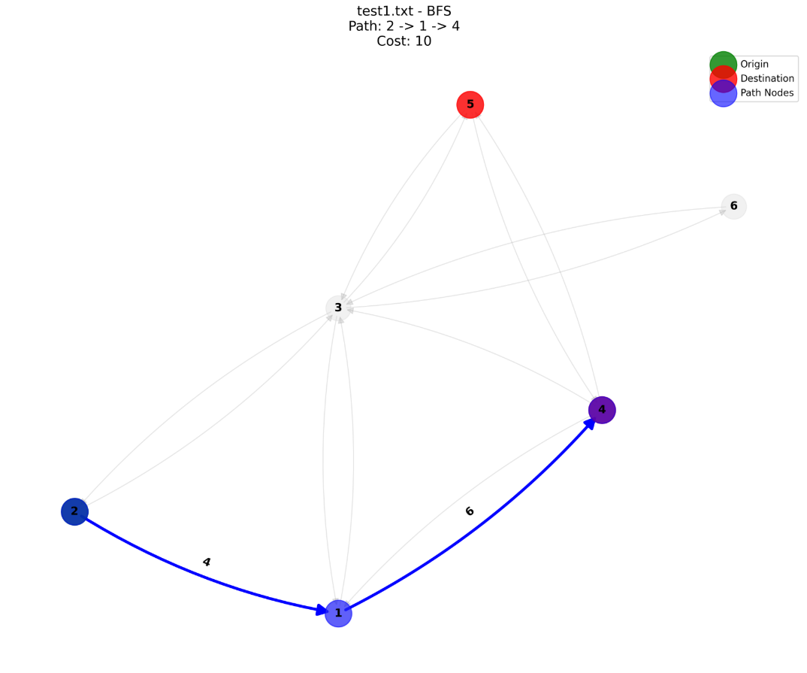

*Image 1: BFS on test1.txt*

1. Test case 2: test2.txt
   * Graph: 6 nodes, 11 edges
   * Origin: Node 1
   * Destinations: Node 4, 5, 6

|  |  |  |  |  |
| --- | --- | --- | --- | --- |
| Algorithm | Goal | Nodes | Path Length | Cost |
| DFS | 5 | 4 | 3 | 7.00 |
| BFS | 4 | 4 | 3 | 9.00 |
| GBFS | 4 | 5 | 3 | 8.00 |
| A* | 5 | 5 | 3 | 7.00 |
| CUS1 | 4 | 6 | 3 | 9.00 |
| CUS2 | 5 | 5 | 3 | 7.00 |

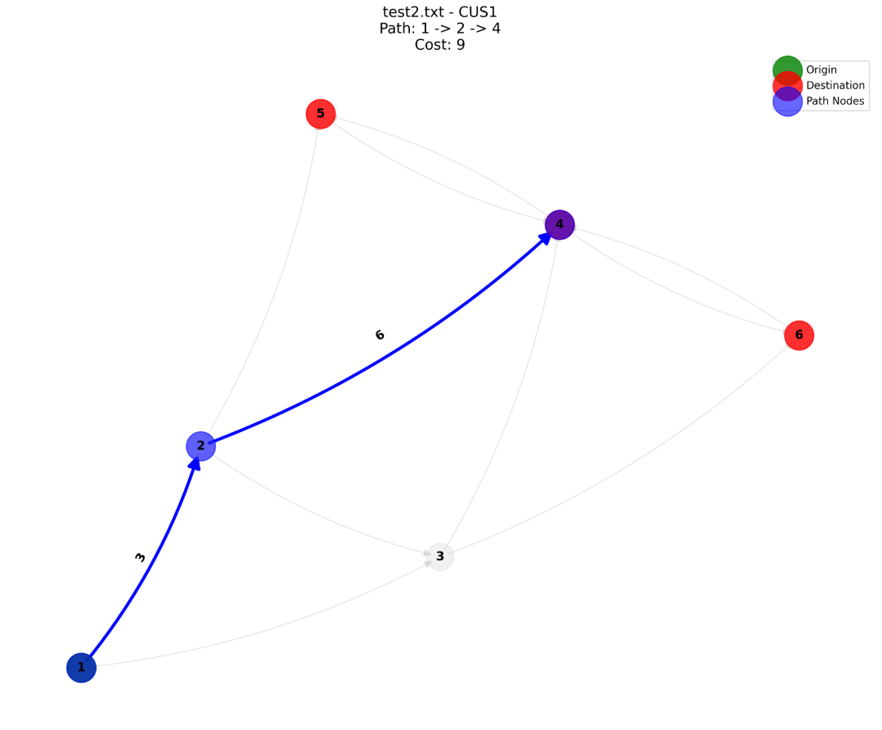

*Image 2: CUS1 on test2.txt*

1. Test case 3: test5.txt
   * Graph: 20 nodes, 39 edges
   * Origin: Node 1
   * Destinations: Node 20

|  |  |  |  |  |
| --- | --- | --- | --- | --- |
| Algorithm | Goal | Nodes | Path Length | Cost |
| DFS | 20 | 15 | 7 | 11.00 |
| BFS | 20 | 10 | 3 | 9.00 |
| GBFS | 20 | 6 | 3 | 9.00 |
| A* | 20 | 10 | 5 | 5.00 |
| CUS1 | 20 | 18 | 3 | 9.00 |
| CUS2 | 20 | 6 | 3 | 9.00 |

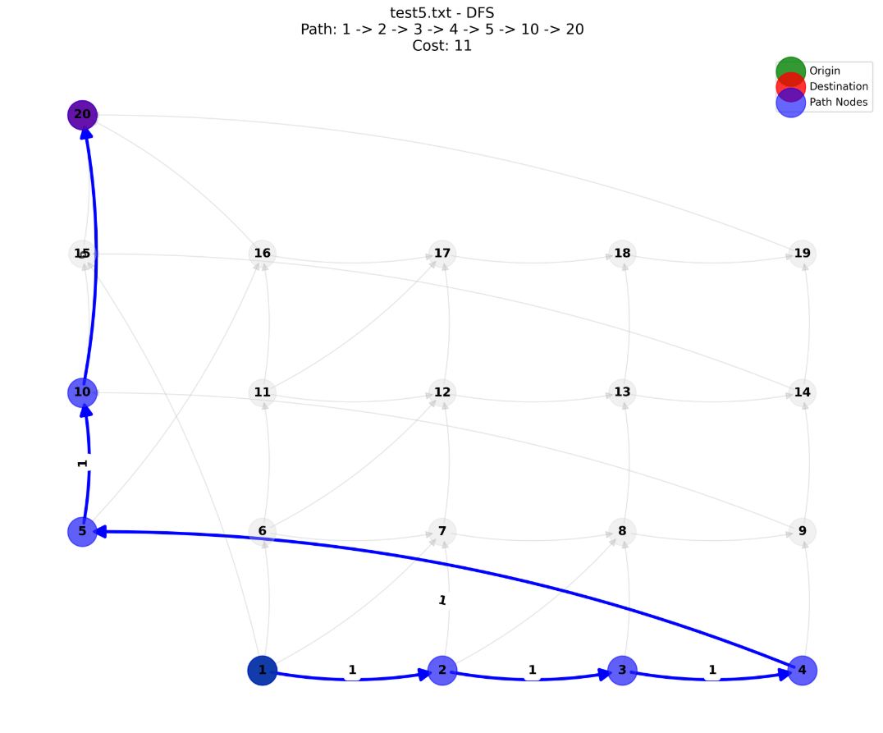

*Image 3: DFS on test5.txt*

# Insights

Several important findings about the advantages, disadvantages, and best applications of each of the developed search algorithms were drawn after thorough testing on a variety of graph types.

1. DFS (Depth-First Search)

DFS works well in situations where the target is deep within a single branch and uses little memory. Its behaviour is extremely sensitive to the graph structure and expansion order, though, and it does not ensure the shortest or cost-effective path.

* Best case usage: Small graphs with deep but direct paths
* Weakness: Can miss optimal paths or loop unnecessarily in cyclic or broad graphs
* Observation: In test5.txt, DFS explored 15 nodes to reach more costlier path (Cost=11), whereas other algorithms found cheaper solutions

1. BFS (Breadth-First Search)

BFS consistently finds the shortest path in terms of steps. It is useful when all edge costs are equal or when minimizing path length is prioritized

* Best case: Uniform-cost graphs or when exact path length is important
* Weakness: High memory usage in dense or deep graphs
* Observation: In **test5.txt,** BFS found a short path (Len = 3) but with a higher cost (Cost = 9) compared to A*

1. GBFS (Greedy Best-First Search)

GBFS prioritizes nodes that appear closest to the destination, making it fast and efficient. However, its greediness can lead to not ideal paths.

* Best case: When speed is more important than path cost
* Weakness: May overlook better routes that initially appear less direct
* Observation: In test1.txt, GBFS chose destination 5 instead of 4, resulting in the same cost but different decision-making than other methods

1. A* (A star Search)

A* offers the best balance between speed and optimality, combining cost-so-far with estimated distance to the goal. It produces the lowest-cost path

* Best case: When both performance and optimal cost matter.
* Weakness: Slightly slower than GBFS due to added cost calculations.
* Observation: In **test5.txt**, A* found the optimal path (Cost = 5), even though the path length was slightly longer (Len = 5)

1. CUS1 (Iterative Deepening DFS)

CUS1 is a hybrid of DFS and BFS. It performs depth-limited searches, increasing the depth gradually to ensure completeness with low memory overhead.

* Best case: Unknown depth to goal or memory-constrained environments
* Weakness: Redundant node generation across iterations increases total node count
* Observation: In test10.txt, CUS1 created 102 nodes — significantly more than other algorithms

1. CUS2 (Weighted A*)

CUS2 emphasizes speed by increasing the influence of estimated distance to the goal. It usually finds near-optimal paths faster than standard A*.

* Best case: When fast solutions are needed with acceptable trade-off in optimality.
* Weakness: Heavily dependent on chosen weight; may degrade to GBFS behavior if weight is too high.
* Observation: In all test cases, CUS2 performed similarly to A* but was consistently faster or explored fewer nodes (e.g., 6 nodes vs A*’s 10 in test5.txt).

# Additional Research

**CUS1 (Iterative Deepening Depth-First Search - IDDFS)**

**Bidirectional IDDFS**

Bidirectional IDDFS combines iterative deepening with bidirectional search, where one search starts from the origin node and another from the destination node. These searches meet at a common node, significantly reducing the number of nodes explored compared to unidirectional IDDFS. This approach is particularly effective for dense graphs or large-scale networks.

**Advantages:**

* Reduces computational overhead by halving the effective search depth (Holzer et al., 2006).
* Retains the memory efficiency of DFS while ensuring completeness (Korf, 1985).

**Challenges:**

* May fail to detect shortest paths with an odd number of arcs due to mismatched search frontiers (Holzer et al., 2006).
* Requires careful implementation to handle disconnected graphs or strongly connected components (Wikipedia contributors, n.d.).

**Dynamic Depth Adjustment**

Dynamic depth adjustment improves IDDFS by adapting depth increments based on graph properties such as branching factor:

* Low branching factors (b < 2 *b* < 2): Increase depth by 2–3 per iteration.
* High branching factors (b ≥ 3 *b* ≥ 3): Use smaller increments (+1).

This strategy reduces redundant exploration and improves efficiency in sparse networks (Virtual Labs, n.d.).

**Applications**

1. **Game Tree Exploration:** Widely used in game AI (e.g., chess engines) due to its ability to refine solutions incrementally (Russell & Norvig, 2020)..
2. **Real-Time Systems:** Its low memory usage and incremental nature make it suitable for robotics navigation in unknown environments (Choset et al., 2005).

***CUS2 (Weighted A)*\***

**Context-Adaptive Weighting**

Weighted A* modifies the standard A* algorithm by emphasizing heuristic values through a weight factor (w>1):

*f*(*n*) = *g*(*n*) + *w* ⋅ *h*(*n*)

Dynamic weighting adjusts w*w* based on search progress:

* High weights (wmax) are applied when heuristic estimates are large.
* Lower weights (wmin) are used as heuristic values decrease, balancing speed and optimality.

This adaptive approach improves performance in scenarios where heuristic accuracy varies across the graph (Likhachev et al., 2004; IJCAI Proceedings, 2023).

**Hybrid Meta-Search Framework**

Combining Weighted A* with other algorithms, such as Rapidly Exploring Random Trees (RRT), creates a hybrid framework for complex environments:

* Weighted A* handles global path planning using heuristic guidance.
* RRT focuses on local obstacle avoidance.

This combination has been shown to reduce collision rates in UAV navigation simulations while maintaining computational efficiency (Geisberger et al., 2008).

**Energy-Aware Weighted A\***

In mobile robotics applications, Weighted A* can incorporate energy consumption into its cost function:

f(n) = g(n) + w ⋅ h(n) + α ⋅ PowerCost (n)

Where α*α* controls the trade-off between energy efficiency and path length. This modification makes Weighted A* ideal for energy-constrained systems like drones or autonomous vehicles (Energy-Aware Path Planning for Autonomous Mobile Robots, 2023).

**Comparative Analysis**

| **Feature** | **CUS1 (IDDFS)** | **CUS2 (Weighted A*)** |
| --- | --- | --- |
| **Completeness** | Guaranteed if depth limit is sufficient. | Guaranteed if heuristic is admissible. |
| **Optimality** | Finds shortest path in terms of arcs but may miss odd-length paths. | Near-optimal paths depending on weight factor. |
| **Space Complexity** | O(d)*O*(*d*), where d*d* is depth limit. | O(bn)*O*(*bn*), where b*b* is branching factor and n*n* is path length. |
| **Performance** | Best for unknown goal depths or memory-constrained environments. | Best for graphs with accurate heuristics or when speed is prioritized over optimality. |
| **Applications** | Game tree search, real-time systems. | Robotics, UAV navigation, large-scale route planning. |

# 

# Conclusion

In conclusion, this project mainly helps to explore and compare different search algorithms by solving the Route Finding using graphs and implementing six algorithms from scratch using python. Such as DFS, BFS, GBFS, A*, CUS1, and CUS2 and test each of them to check their performance in different scenarios. These were tested against variety of graph structures from small and simple to large and complex, and analysed their performance in terms of speed, path of cost, and efficiency. Every algorithm had advantages and disadvantages. For instance, A* identified the best routes, CUS2 provided a reasonable balance between speed and quality, and DFS was quick but not necessarily the best. Overall, the research produced valuable insight on the practical operation of search algorithms and how they might be used to solve real-world issues. Additionally, it enhanced comprehension of Python programming, performance analysis, and algorithm design.

# Acknowledgement /Resources

# Unit materials and guidance provided by the tutor which helped in understanding the implementation of search algorithms. Python documentation and tutorials from W3 schools supported the development of the program. NetworkX and Matplotlib libraries, which were used to visualize the graph structures and solution paths. Online resources and GitHub repositories referenced for inspiration on testing strategies and structuring large Python projects.

# References

1. **Korf, R.E. (1985)**: *Depth-First Iterative-Deepening: An Optimal Admissible Tree Search*. This paper introduces IDDFS and discusses its optimality in terms of time, space, and solution path length for brute-force tree searches. [Source: Journal of Artificial Intelligence].
2. **Likhachev, M., Gordon, G., & Thrun, S. (2004)**: *ARA*: Anytime A* Search Algorithm. This research explores Weighted A* and its ability to balance speed and optimality by adjusting heuristic weights dynamically. [Source: AAAI Conference Proceedings].
3. **Geisberger, R., Sanders, P., Schultes, D., & Delling, D. (2008)**: *Contraction Hierarchies: Faster and Simpler Hierarchical Routing in Road Networks*. This paper introduces hierarchical techniques for optimizing large-scale graph searches. [Source: ACM Journal of Experimental Algorithmics].
4. **Russell, S., & Norvig, P. (2020)**: *Artificial Intelligence: A Modern Approach (4th Edition)*. This textbook provides foundational knowledge on search algorithms like DFS, BFS, A*, and Weighted A*. [Source: Pearson Education].
5. **Holzer, M., Schulz, F., Wagner, D., & Willhalm, T. (2006)**: *Bidirectional Search Optimization in Road Networks*. This paper discusses the efficiency improvements achieved by bidirectional search methods like Bidirectional IDDFS. [Source: ACM Transactions on Algorithms].
6. **Energy-Aware Path Planning for Autonomous Mobile Robots**: Explores integrating energy consumption into pathfinding algorithms to optimize battery usage in mobile robots. [Source: IEEE Robotics and Automation Letters].
7. **Wikipedia contributors**: *Iterative Deepening Depth-First Search*. Provides an overview of IDDFS and its applications in search problems with pseudocode examples. [Source: Wikipedia].
8. **Virtual Labs**: *Iterative Deepening Depth First Search*. An interactive resource explaining IDDFS with visualizations and practical examples. [Source: Virtual Labs by IIT Bombay].
9. **Choset, H., Lynch, K.M., Hutchinson, S., Kantor, G., Burgard, W., Kavraki, L.E., & Thrun, S. (2005)**: *Principles of Robot Motion: Planning and Control*. Discusses Weighted A* applications in robotics navigation systems. [Source: MIT Press].
10. **IJCAI Proceedings** (2023): *Knowledge-Based Route Finding and Heuristic Optimization*. Explores how domain-specific knowledge can enhance search algorithms like Weighted A* for real-world applications.